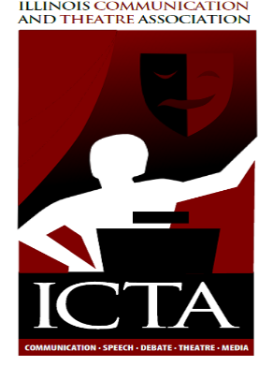
MEMBERSHIP- PR HIGHER EDUCUATION
2014 ANNUAL REPORT

At the post-convention Board Meeting in 2013 co-chairs were elected to the PR/Membership position. The rationale for electing co-chairs included the recognition of the challenges faced by one person trying to connect with both secondary and higher education faculty across the state. Amanda Ams is the secondary education co-chair and I am the higher education co-chair. This report comprises the activities of the higher education co-chair for 2014:
- Tina sent out certificates and thank you letters to the 2013 conference participants. She passed along information to both Amanda and I to help us with PR/Membership tasks. Many thanks to Tina for the work she has done through the years in her role as PR/Membership for both secondary and higher education.
- A call for proposals was sent out in the spring, and I helped the Higher Ed. Committee Chair get the word out to the Illinois higher education community. Including posting a call for proposals on the National Communication Association’s Listserv.
- A database of Communication and Theatre faculty contacts at Illinois community colleges, four-year colleges and universities is being complied with the goal of increasing the membership and getting the ICTA name in front of more people in higher education across the state.
- Representatives from higher ed. textbook companies were contacted about sponsoring the conference and a sponsorship form was developed and approved by the Board designating levels of sponsorship from bronze ($200.00) to platinum ($1000.00).
- The following sponsors signed on for the 2014 conference: Cengage, McGraw-Hill, Pearson, Oxford and Kendall-Hunt. Also, thanks to Judy Santacaterina NIU will be covering the cost of the Saturday breakfast. Sponsorship totals to date amount to almost $2,000.00. Also, four of the textbook companies plan to set up booths at the conference as well.
- Over 30 email invitations were personally sent to community college contacts across Illinois encouraging conference attendance.
- A conference session feedback form was developed for 2014 as a way to assess participant reaction to conference sessions and to aid in planning next year’s conference.
- A survey instrument used in 2009 is being revised to capture additional information about attendee preferences and interests to aid in planning for the future.
- The New Member form, Mentor form, and Conference Highlights form will be updated for the conference. Amanda and I worked together to plan for the 2014 New Members Orientation sessions.
- Pens with the ICTA name were recommended as conference giveaways. Pens are also good to take to other conferences throughout the year to promote the ICTA name. The Central Office purchased a quantity of these for the conference.

Respectfully Submitted,
Julie Weishar, Membership-PR Co-Chair

